Sample Paper- 2013
Subject: Computer Science
Class 12th
Time: 3 hours Max. Marks: 70
Instructions:
- All questions are compulsory
- Programming language is C++
Q.1 (a) What is difference between Actual and Formal parameter? Also, give a suitable C++ code to illustrate both. 2
(b) Write the names of the header files to which the following belong: 1
(i) strlen() (ii) frexp
(c) Rewrite the following program after removing the syntactical errors (if any). Underline each correction. 2
#include<iostream.h>
struct pixels
{
Int color, style;
}
Void showpoint(int p);
{
cout<<p.color,p.style<<endl;
}

(d) Find the output of the following program: 3
#include<iostream.h>
void change(int a[ ], int count)
{
for(int c=1;c<count; c++)
a[c-1]+=a[c];
}
void main()
{
int b[ ]={3,4,5}, c[ ]={10,20,30,40}, d[ ]={900,1200};
change(b,3);
change(c,4);
change(d,2);
for(int g=0;g<3;g++)
{
cout<<b[g]<<”#”;
cout<<endl;
}
for(int g=0;g<4;g++)
{
cout<<c[g]<<”#”;
cout<<endl;
}
for(int g=0;g<2;g++)
{
cout<<d[g]<<”#”;
cout<<endl;
}
}
(e) Find the output of the following program: 2
#include<iostream.h>
void execute(int m)
{
int t = m;
m+=t;
}
void main()
{
int A=50, B=20;
execute(b);
cout<<A<<B<<endl;
}
(f) In the following program, if the value of N given by the user is 20, what maximum and minimum vales the program could possibly display? 2
#include<iostream.h>
#include<stdlib.h>
void main()
{
In N, g;
ran();
cin>>N;
g=ran(N-10)+10;
cout<<g<<endl;
}

Q.2 (a) What do you understand by Polymorphism? Give a suitable example of the same. 2
(b) Answer the question (i) and (ii) after going through the following program: 2
class match
{
int time;
public:
match() //Function 1
{
time=0;
cout<<”Match commences”<<endl;
}
void detail() //Function 2
{
cout<<”Inter Section Football Match”<<endl;
}

match(int a) //Function 3
{
time=dur;
cout<<”Another Match begins now”<<endl;
}
~match() //Function 4
{
cout<<”Like Previous Match”<<endl;
}
};

- In OOPs, what is Function 4 referred as and when does it get invoked/called?
- In OOPs, which concept is illustrated by unction 1 and Function 3 together?

(c) Define a class TEST in C++ with following description: 4
Private Members
* TestCode of integer typr
* Description of string type
* NoCandidate of integer type
* CenterTeqd of integer type
Public Members
* A function Schedule() to allow user to enter values for TestCode
* A function DispTest() to allow user to view the content of all the data members.
(d) Answer the questions (i) to (iv) based on the following code: 4
class PUBLISHER
{
double Turnover;
char Pub[12];
protected:
void Register();
public:
PUBLISHER();
void Enter();
void Display();
};
class BRANCH
{
char City[20];
protected:
float Employee;
public:
BRANCH();
void Haveit();
void Giveit();
};
class AUTHOR : private BRANCH, public PUBLISHER
{
Int ACode;
char Aname[20];
float Amount;
public:
AUTHOR();
void Start();
void Show();
};
- Write the names of data members which are accessible from objects belonging to class AUTHOR.
- Write the names of all the member functions which are accessible from objects belonging to class BRANCH.
- Write the names of all the members which are accessible from member functions of class AUTHOR.
- How many bytes will be required by an object belonging to class AUTHOR?

Q.3 (a) Write a function in C++ to combine the contents of two equi-sized arrays X and Y by their corresponding
elements as the formula X[i]+Y[i], where the value of I varies from 0 to N-1 and transfer the resultant
content in the third same sized array Z. 3
(b) An array P[20][30] is stored in the memory along the column with each of the element occupying
2 bytes, find the Base address of the array, if an element P[2][10] is stored at the memory location 5000. 3
(c) Write a function in C++ to find sum of rows from a two dimensional array. 4
(d) Write a function in C++ to print the left diagonal elements of a double dimension array of equi-sized. 2
(e) Evaluate the following postfix notation of expression: 2
True, False, OR, True, True, False, NOT, OR, AND

Q.4 a. Reduce the following Boolean Expression using K-Map: 1
F(A,B,C,D) = (0,1,2,10,11)
b. An array A[50][100] is stored in the memory along the column with each of the element occupying
2 bytes, find the Base address of the array, if an element A[20][50] is stored at the memory location 1000. 2
c. What do you understand by call by value and call by reference. Also, give a suitable C++ code to illustrate
both. 3

Q.5 a. What do you understand by candidate key? Give a suitable example to illustrate the same. 2

Consider the following tables GAMES and PLAYER and answer (b) and (c) parts of this question:
Table: GAMES

GCode | GameName | Type | Number | PrizeMoney | ScheduleDate
101 | Carrom | Indoor | 2 | 5000 | 23-Jan-2004
102 | Badminton | Indoor | 2 | 12000 | 12-Dec-2003
103 | Table Tennis | Indoor | 4 | 8000 | 14-Feb-2004
105 | Chess | Indoor | 2 | 9000 | 01-Jan-2004
108 | Lawn Tennis | Outdoor | 4 | 25000 | 19-Mar-2004

Table: PLAYER

PCode | Name | GCode
1 | Nabi Ahmad | 101
2 | Ravi Sahai | 108
3 | Jatin | 101
4 | Nazneen | 103

b. (i) To display the names of all GAMES with their codes. 1
(ii) To display details of those GAMES which are having prize money more than 7000. 1
- To display the content of the GAMES table in ascending order of schedule date. 1
- To display sum of Prize money for each type of GMAES. 1
c. (i) SELECT COUNT (DISTINCT Number) FROM GAMES; 0.5
(ii) SELECT MAX(ScheduleDate), MIN(ScheduleDate) FROM GAMES; 0.5
(iii) SELECT GameName, Type FROM GAMES G, PLAYER P
WHERE G.GCode=P.PCode AND P.Number=10; 0.5
- SELECT DISTINCT GCode FROM PLAYER; 0.5

Q.6 a. State and verify Absorption Laws using truth table. 2
b. Write the equivalent Boolean Expression for the following logic circuit 2

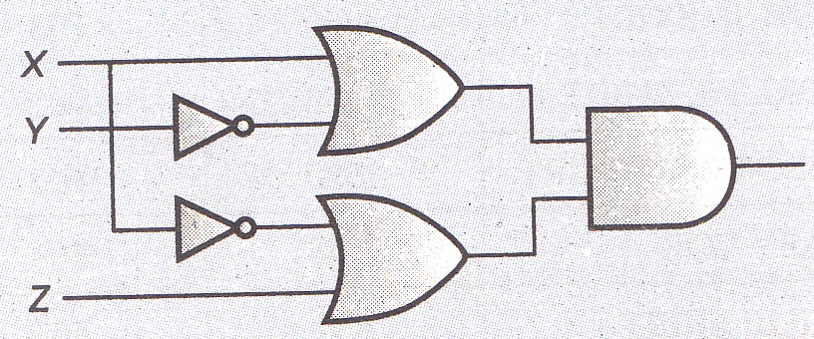

- Write the POS form of a Boolean function F, which is represented in a truth table as follows: 1

P | Q | R | G
0 | 0 | 0 | 0
0 | 0 | 1 | 0
0 | 1 | 0 | 1
0 | 1 | 1 | 0
1 | 0 | 0 | 1
1 | 0 | 1 | 0
1 | 1 | 0 | 1
1 | 1 | 1 | 1

d. Reduce the following Boolean Expression using K-Map: 3
F(A,B,C,D) = (0,1,2,4,5,6,8,10)

Q.7 a. Define the term hacking? How a Hacker is different from Cracker. 1
b. Write two examples of Client side scripting languages. 1
c. How firewall protect our networking. 1
d. What do you mean by IP address? Give one example. 1
e. Oxford University has set up its new center at Mumbai for its office and web based activities.
The company compound has 4 buildings as shown in the diagram below: 4

Mumbai

A
B

D

C

Distance between buildings is as follows: No. of computers per building is as follows:

A and B | 50m
B and C | 70m
C and D | 25m
A and D | 170m
B and D | 152m
A and C | 90m
A | 12 computers
B | 20 computers
C | 24 computers
D | 10 computers

- Suggest a cable layout of connections between the buildings.
- Suggest the most suitable place (i.e., building) to house the server of this organization with a suitable reason.
- Suggest the placement of the following devices with justification:
  - REPEATER
  - HUB/SWITCH
- The organization is planning to link front office situated in the city in a hilly region where cable connection is not feasible, suggest an economic way to connect it with reasonably high speed.
f. How Trojan Horses are different from Worms. 1
g. Give two examples of Proprietary Software. 1

Tips:

- Attempt all parts of a question at one place.
- As C++ is a case sensitive language, special care should be taken while writing codes.
- Don’t leave any question or part unattempted, as no negative marking is there.
- Answer must be to the point i.e., don’t write anything extra which is not asked.
- Don’t make any hurry while attempting questions as a small error will spoil your answer.
- Read carefully before attempting questions.
- Cross check the output question at least one time.
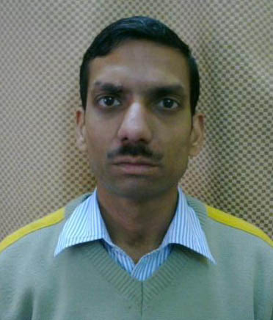
SANT SHRI ASARAMJI PUBLIC SCHOOL, AGRA

Mr. Vishwajit Singh Pal
PGT - I.P. (065) and C.S. (083)
Sant Shri Asaramji Public School, Agra

For any other queries:
E-mail: vishwajit@fastmail.fm, vishwajit14@gmail.com
Mob. +919897695915

